Justin Hu, Marcus Pearce, Vincent Hwang

APCS Peck

Period 5

5/23/17

**Peckman User Manual**

**Overview and Objective**

Peckman is a re-creation of Pacman. Peckman is a game with five characters: Pacman (user), Red Ghost, Pink Ghost, Blue Ghost and Orange Ghost. In order to win the game, Pacman must eat all the dots in the maze.

**Download Greenfoot**

* Greenfoot must be download in order to play Peckman
* Link to download Greenfoot (<https://www.greenfoot.org/download>)

**Rules and Tips**

* Avoid the ghosts
  + Pacman has three lives and loses a life if he comes in contact with a ghost
  + If Pacman loses all three lives, game over.
* Eat big dots to kill ghosts
  + Hype mode allows Pacman to eat the Ghosts for a limited amount of time
  + In hype mode, ghosts avoid Pacman and turn blue
* High scores
  + Eat as many dots as possible to maximize your score
  + Killing multiple ghosts in a row in a single hype mode gives a bonus

**Controls and Instructions**

* Click run.simulation in order to start the game 
* Use arrow keys to control movements
  + Up key = move up
  + Down key = move down
  + Right key = move right
  + Left key = move left

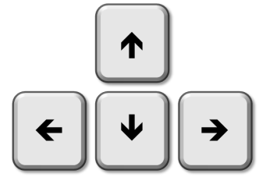

**Scenarios**

*Start Screen*  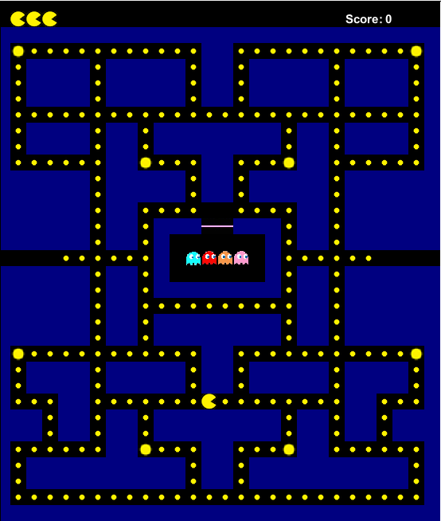

*Ghosts in Pursuit*  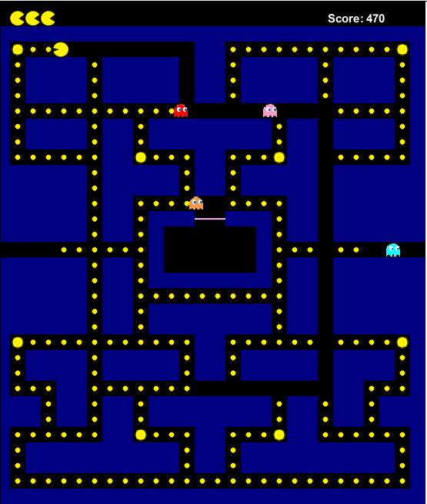

*Hype Mode*  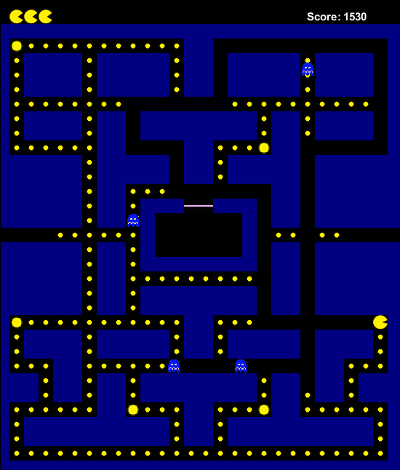

*Game Over*

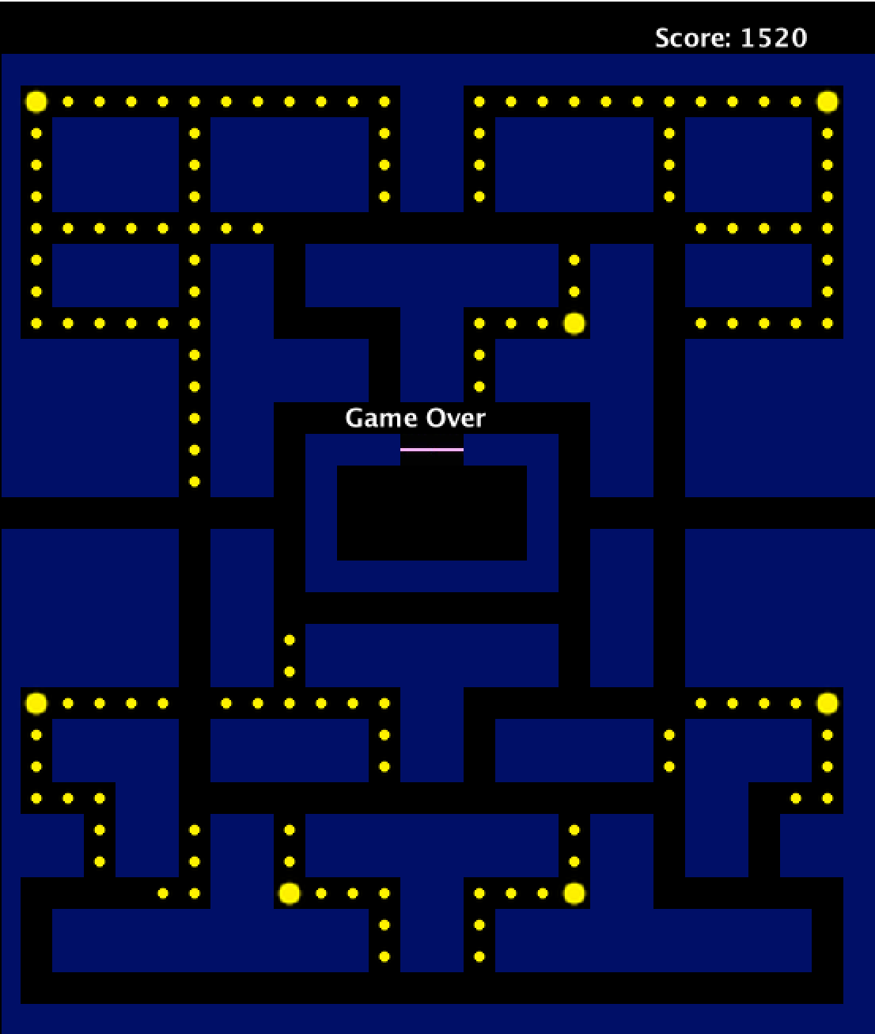

*Win Screen*

